USER MANUAL
DocExtract - Intelligent Document Processing

Document Control
Document History
Version | Date | Author | Description
1.0 | 08/07/2026 | DocExtract Project Team | Initial document.
1.1 | 23/07/2026 | DocExtract Project Team | Selectable extraction models on upload; audit log 60-entry retention and pagination; Processing Log pagination and model filter; persistent RAG chat history with sidebar; admin permanent document deletion.

Document Distribution
# of Copy | Description | Location
1 set | Master copy | DocExtract project repository (Works/)
1 set | DocExtract project documentation | Project team shared folder

Table of Contents
Definisi
1. Sign In
2. Upload a Document (Single & Batch)
3. View Extraction Results
4. Review & Correct Fields
5. Approve / Reject a Document
6. Export to CSV / JSON
7. Dashboard (Accuracy Evaluation & ROI Calculator)
8. Audit Log
9. Settings (Validation Rules & User Management)
10. Model Speed (Performance) Page
11. RAG Assistant (Document Chat)
12. Admin Document Deletion
User Manual Approval

Definisi
DocExtract is an Intelligent Document Processing application. A user uploads an invoice, purchase order, or receipt; a local multimodal vision model (Qwen3-VL-4B, served by LM Studio) reads the document and returns structured data; business rules validate the data; a staff reviewer corrects and approves flagged documents; and approved data is exported to CSV/JSON and a mock downstream API.
Key terms used throughout this manual:
- Document types: Invoice, Purchase Order, Receipt - the three document types DocExtract can extract.
- Extraction: the automatic reading of a document's fields by the vision model.
- Validation: automated business-rule checks (e.g., line items sum to subtotal, subtotal + tax = total, PPN 11%, required fields) that flag possible issues.
- Status: a document's place in the workflow - extracted, in_review, flagged, approved, or rejected.
- Confidence: a heuristic 50–99% score (floored at 50) indicating how much a document may need review.
- Roles: user (uploads documents and views their own results), staff (reviews, corrects, and approves/rejects documents), and admin (manages users, validation rules, and monitoring).
- Audit Log: a record of every significant action taken in the system (login, upload, correction, approval, rejection, export, settings change, document deletion). Only the 60 most recent entries are retained.

1. Sign In
Any role (user / staff / admin) signs in with an email and password. A wrong password is rejected with an error message, and the attempt is recorded in the audit log.
Langkah | Kegiatan
1 | Open the DocExtract application in your browser.
2 | On the Sign In page, choose a demo account tab (User / Staff / Admin) or enter your own registered email and password.
3 | Click "Sign In".
4 | You are authenticated and redirected to the Upload page (or your role's default landing page).
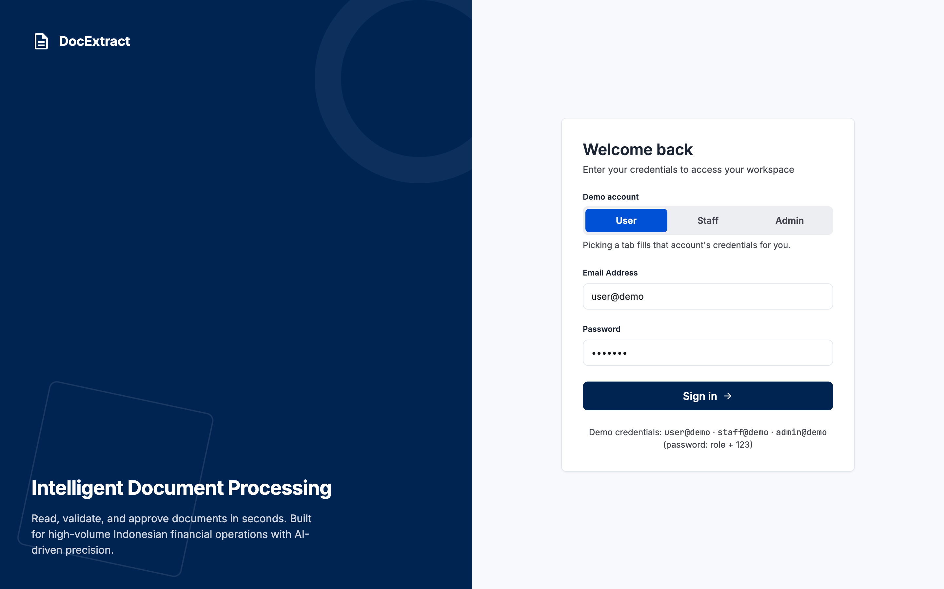
Figure 1 - Sign In page with demo-account tabs

2. Upload a Document (Single & Batch)
Supports both a single document and a multi-file batch upload; each document keeps its own type selection. An extraction-model picker (filled by GET /models) lets you choose which vision model reads the documents.
Langkah | Kegiatan
1 | Go to the Upload page from the sidebar.
2 | Drag and drop one or more documents (invoice, purchase order, or receipt) into the upload area, or click to browse for files.
3 | For each file, select its document type.
4 | In the "Model" dropdown, choose the extraction model for this run: Qwen3-VL-4B (local, default), MiniCPM-V (local), or Gemini (hosted - documents are sent off this machine; the option is disabled when its API key is not configured).
5 | Click "Extract" for a single document, or "Run Batch" to process multiple files.
6 | Wait for the progress indicator - files are extracted one at a time by the local vision model.
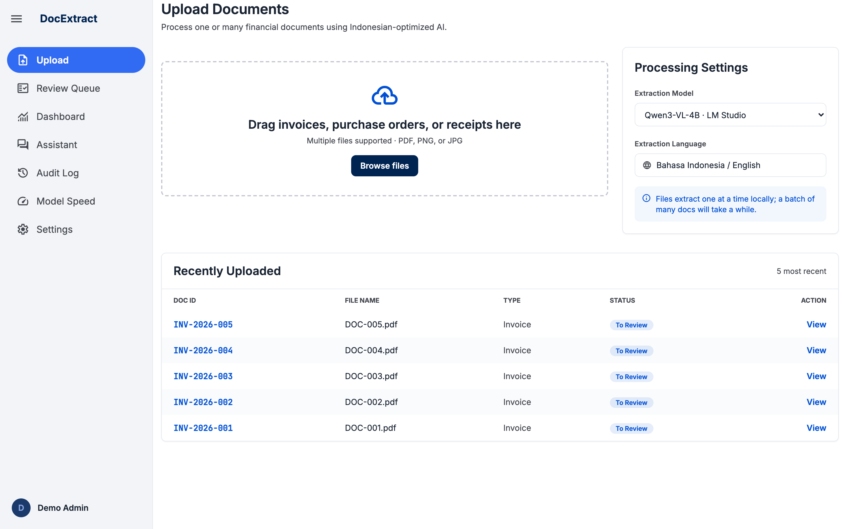
Figure 2 - Upload page with the extraction-model picker

3. View Extraction Results
Lets a user confirm what the model read directly against the source document image.
Langkah | Kegiatan
1 | After extraction finishes, the source document preview appears on the left and the extracted fields appear on the right.
2 | Fields the model could not find are marked with a "Missing" badge.
3 | A confidence percentage is shown above the extracted fields.
4 | Open "My Documents" to see every previously uploaded document, its type, status, and confidence.
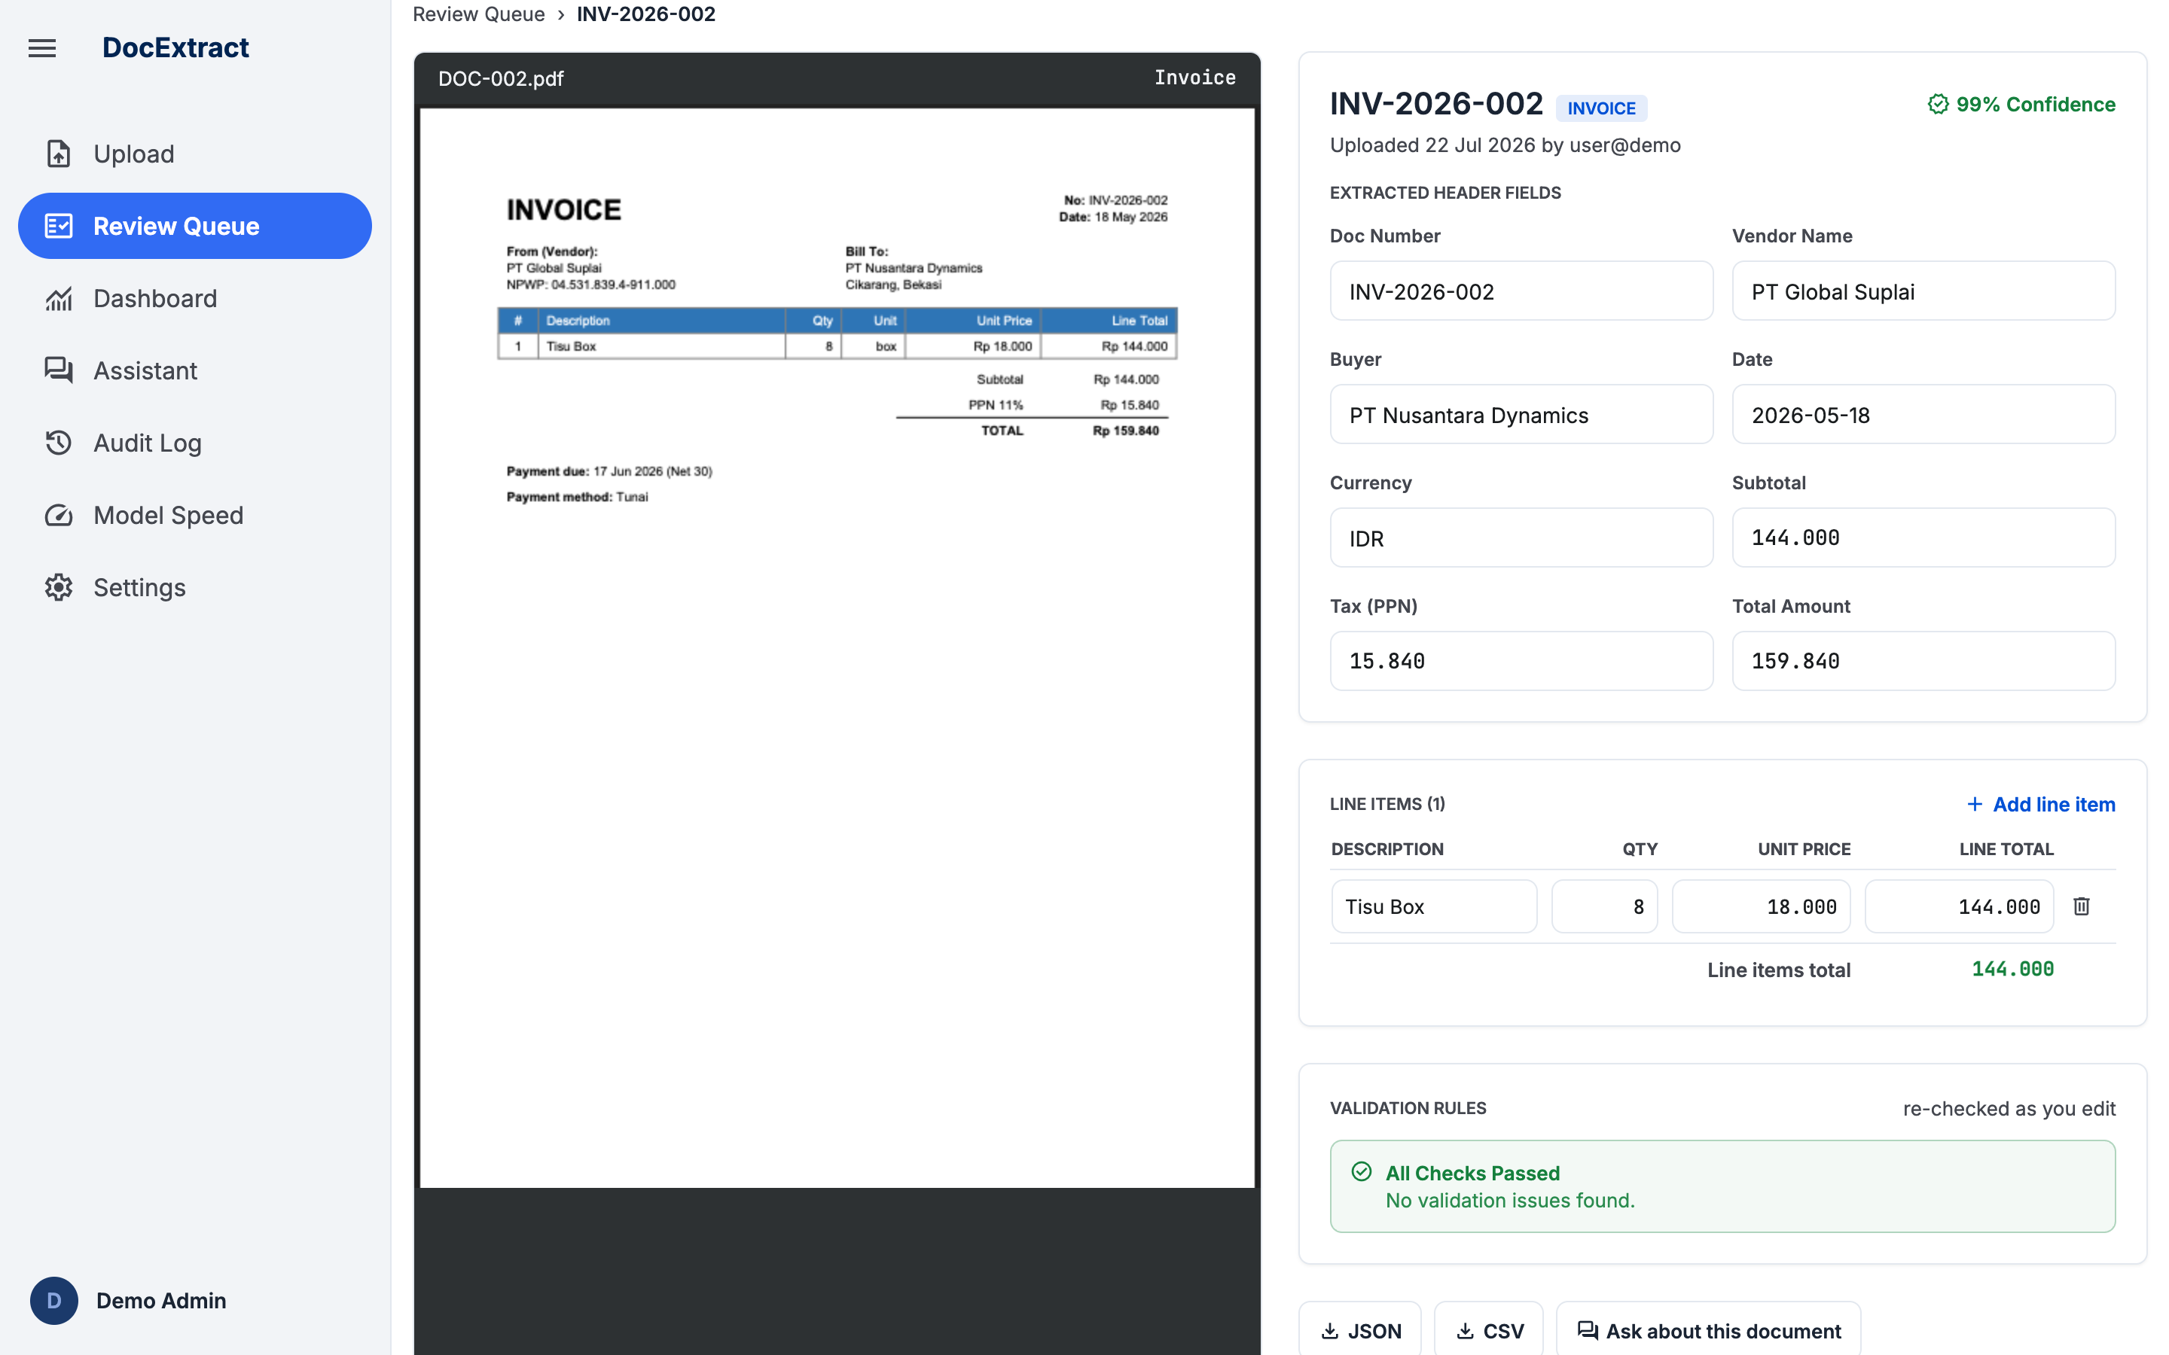
Figure 3 - Extraction results beside the source document

4. Review & Correct Fields
The core human-in-the-loop step: only documents flagged by validation typically need this level of attention.
Langkah | Kegiatan
1 | Sign in as staff (or admin) and open the Review page.
2 | Select a flagged or in-review document from the document list.
3 | Compare the source document preview against the extracted fields.
4 | Edit any incorrect field directly in the form (missing fields are highlighted).
5 | Click "Save Corrections" to re-run validation on the updated data.
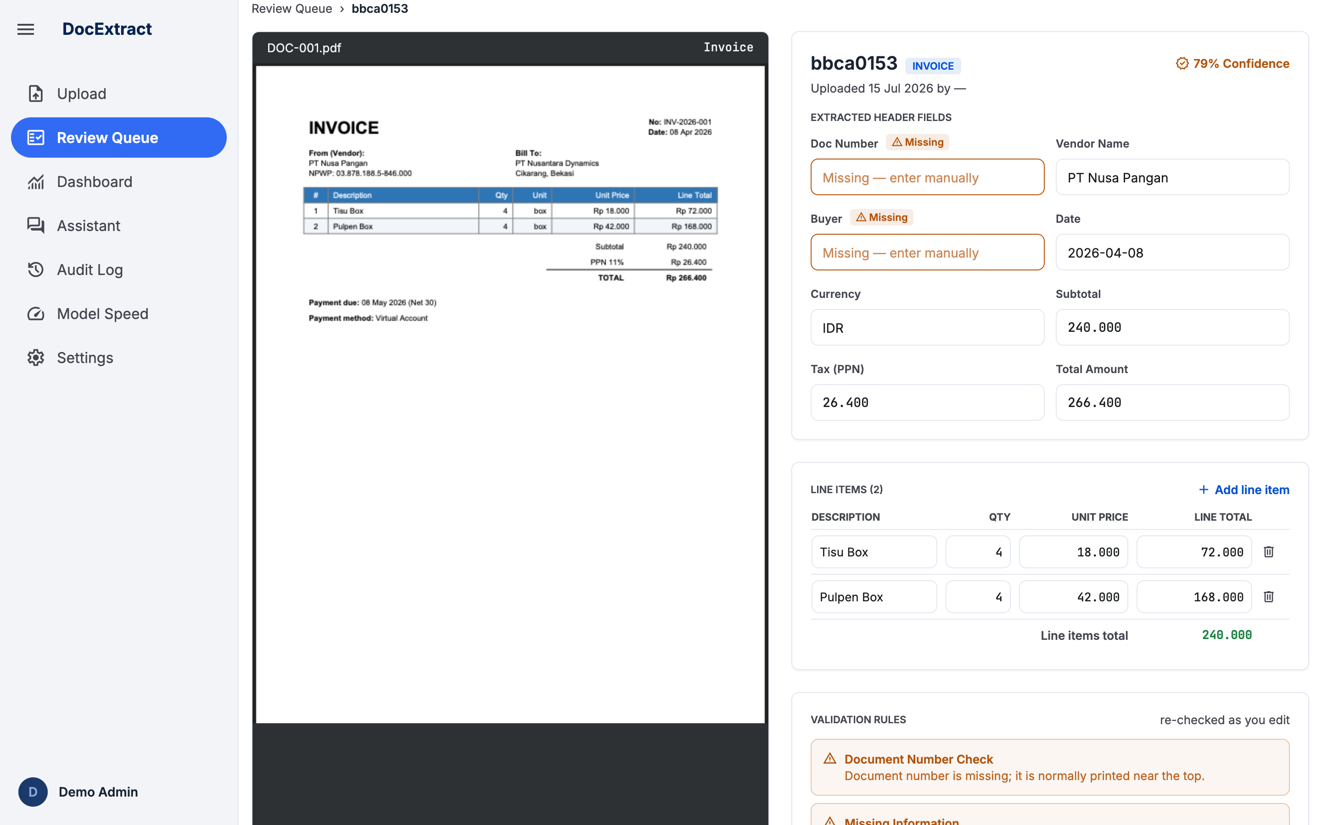
Figure 4 - Review of a flagged document (missing fields highlighted)

5. Approve / Reject a Document
Approval posts the record to the downstream mock API; rejection excludes the document from export.
Langkah | Kegiatan
1 | From the Review page, open a document that has been corrected (or is already clean).
2 | Check the Validation Rules panel for any remaining issues (Calculation Mismatch / Missing Information).
3 | Click "Approve & Export" to approve the document, or "Reject" to reject it.
4 | The document's status updates immediately and the action is recorded in the audit log.
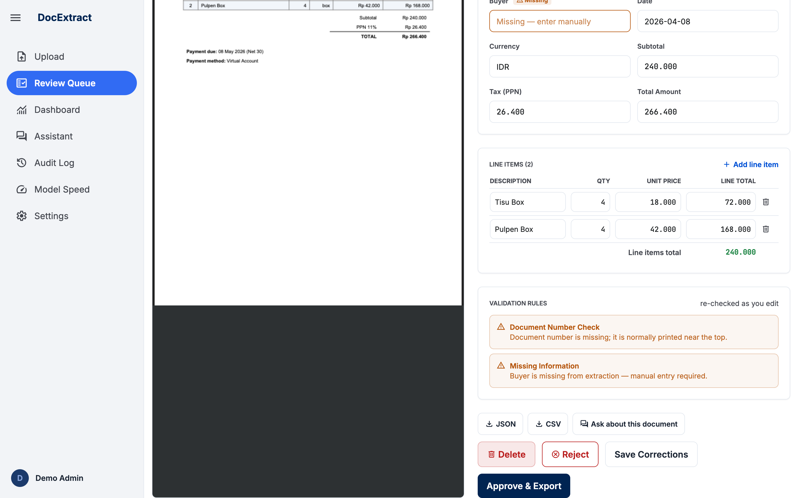
Figure 5 - Validation panel with Approve / Reject / Save Corrections actions

6. Export to CSV / JSON
Only approved documents are exportable - a document must clear human review before its data leaves the system.
Langkah | Kegiatan
1 | Open an approved document from My Documents or the Review page.
2 | Click "Export CSV" or "Export JSON" to download that document's data in the chosen format.
3 | To export every approved document at once, use the bulk "Export All Approved" (CSV) action on the Dashboard or My Documents page.
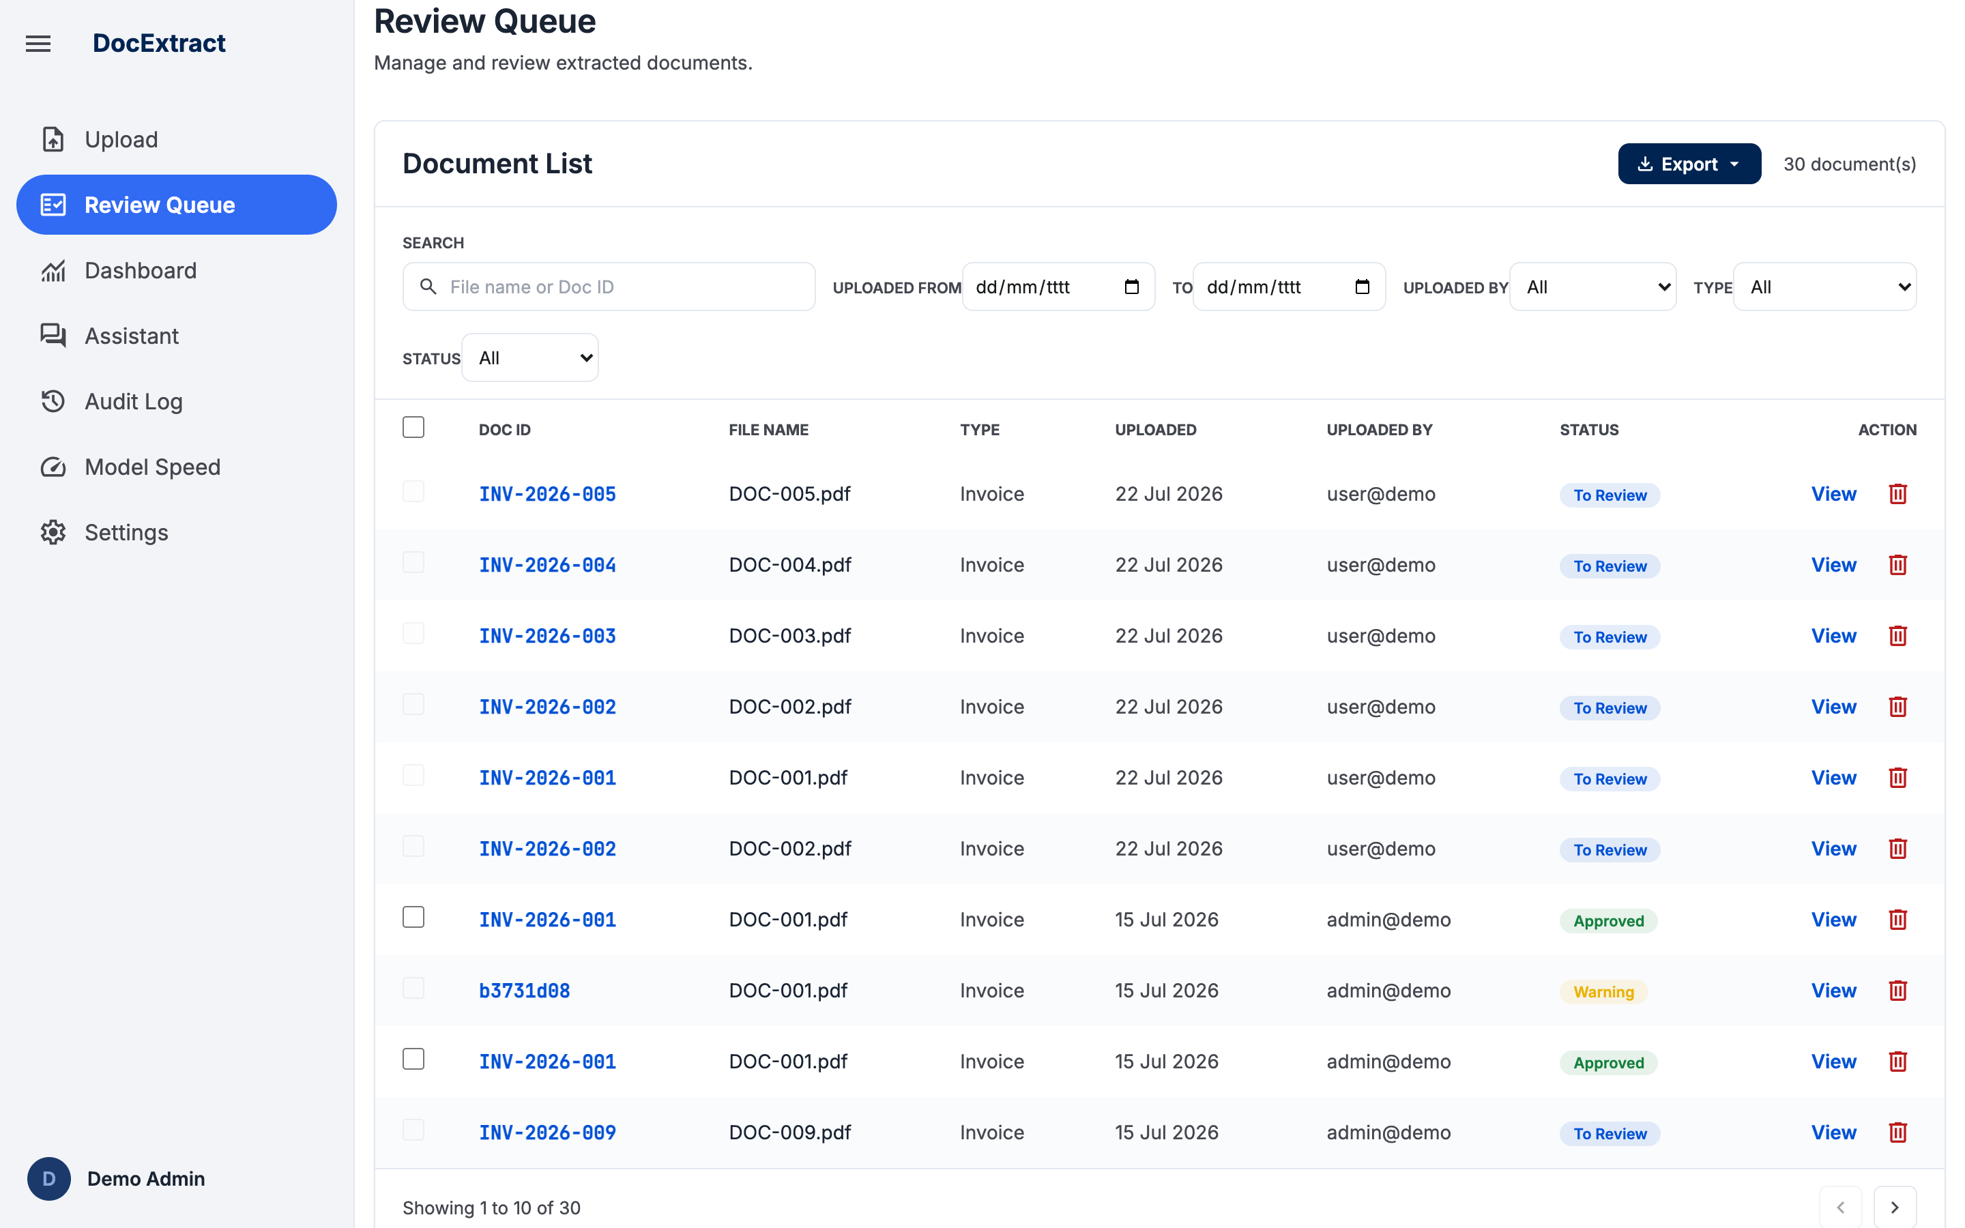
Figure 6 - Document list with per-row and bulk export controls

7. Dashboard (Accuracy Evaluation & ROI Calculator)
Combines deliverable #5 (accuracy evaluation) and deliverable #6 (cost-benefit business case) in one screen.
Langkah | Kegiatan
1 | Sign in as admin and open the Dashboard.
2 | In the "Model Accuracy" card, click "Run Evaluation" to compare extractions against the labelled ground-truth documents.
3 | Watch the live progress bar; overall and per-document-type accuracy are shown once the run finishes.
4 | Scroll to the "Cost-Benefit vs. Manual Entry (ROI)" card and adjust assumptions (monthly volume, staff wages, manual/review minutes) to see updated savings and payback period.
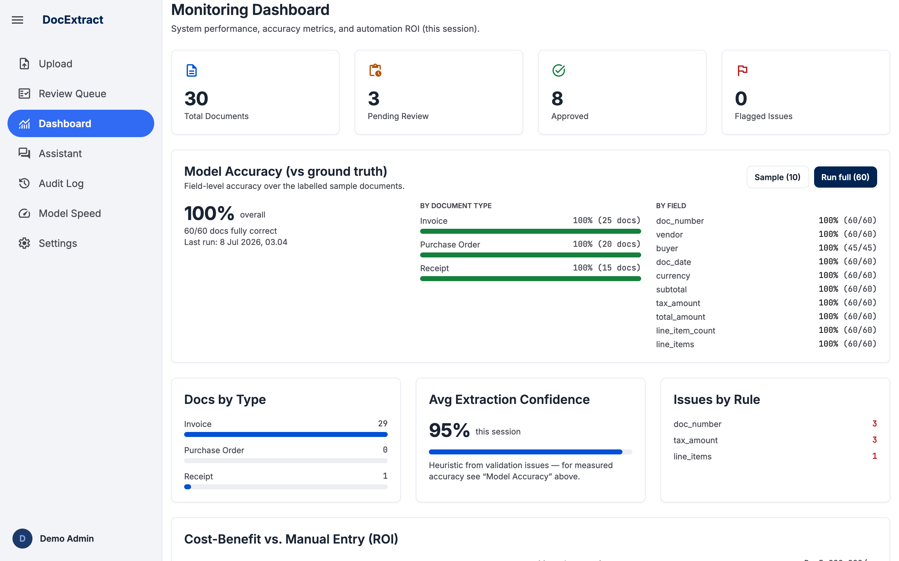
Figure 7 - Monitoring dashboard: accuracy evaluation and metrics

8. Audit Log
Provides a recent-activity trail for accountability and troubleshooting. The system retains only the 60 most recent entries; older entries are trimmed automatically to keep the log lightweight.
Langkah | Kegiatan
1 | Sign in as admin and open the Audit Log page.
2 | Browse the list of recorded actions: login, login_failed, upload, update, approve, reject, status_change, export, eval_run, settings_update, user_create, user_delete, and delete (permanent document deletion by an admin).
3 | Each entry shows the actor's email, role, action type, affected document (if any), timestamp, and a human-readable detail summary.
4 | The table shows 30 entries per page - use the "Prev" / "Next" buttons below the table to move between pages.
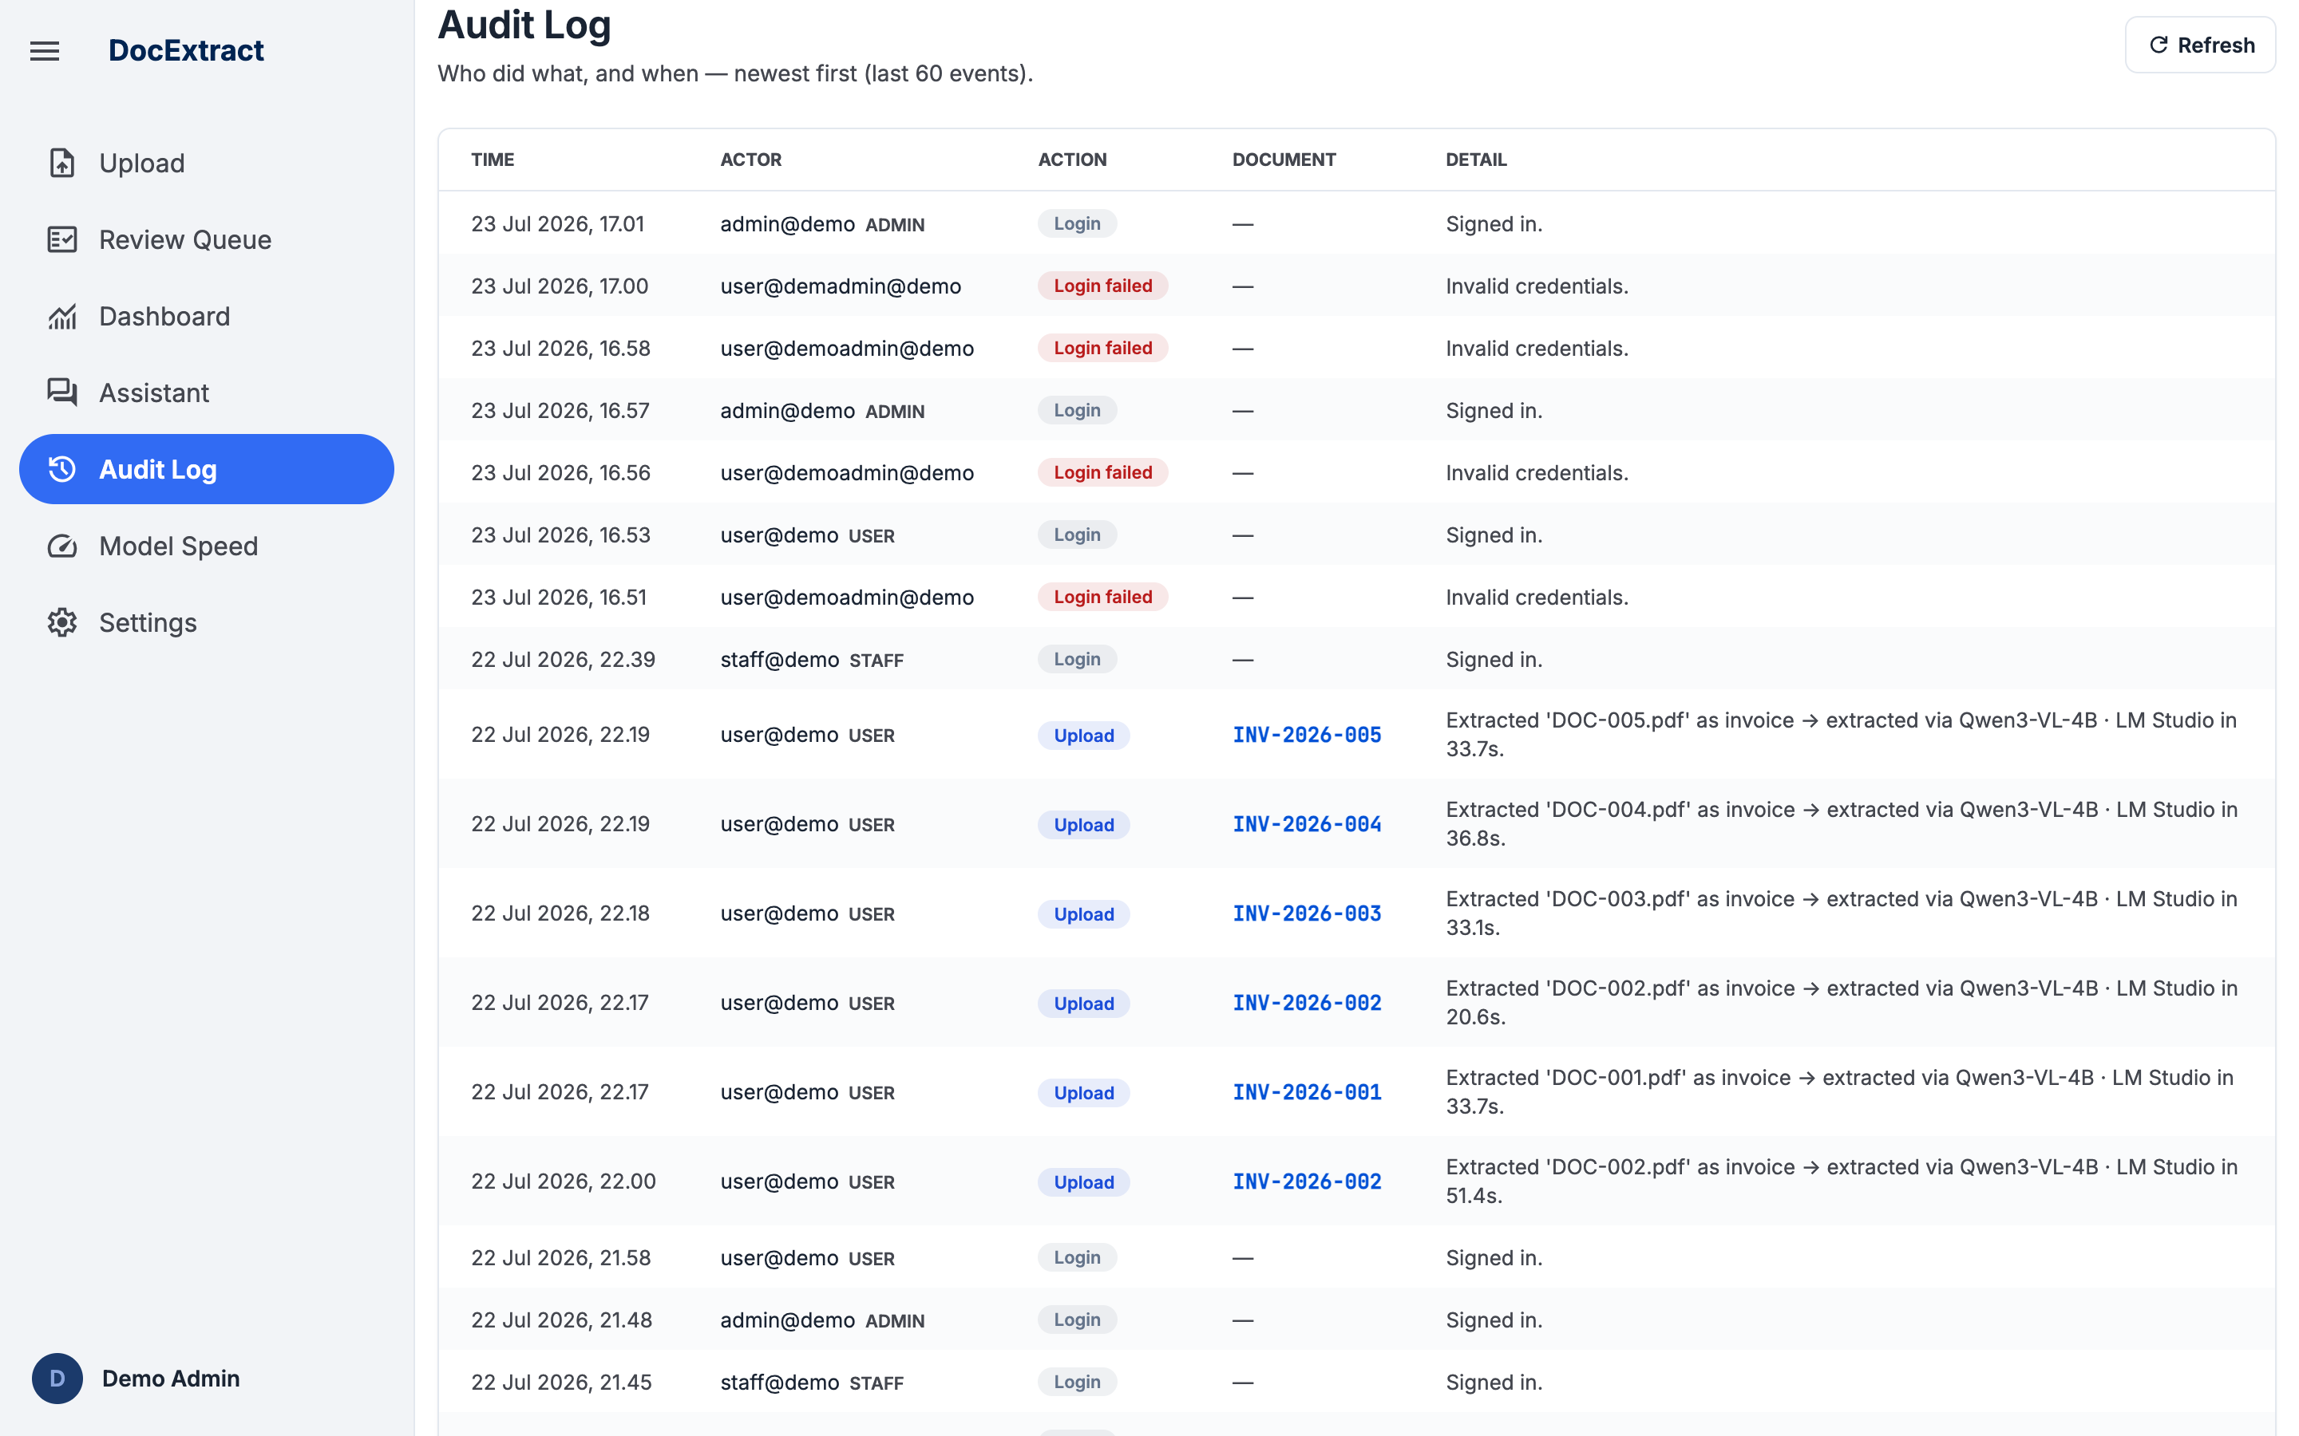
Figure 8 - Audit Log (last 60 events, paginated)

9. Settings (Validation Rules & User Management)
Lets an admin tune the business rules used across the whole pipeline without touching code.
Langkah | Kegiatan
1 | Sign in as admin and open Settings.
2 | Under "Validation Rules", adjust the PPN rate, reconciliation tolerance, or low-confidence threshold, then click Save - the new values apply to subsequent extractions and corrections.
3 | Under "User Management", review the list of registered users and their roles.
4 | To add a user, fill in email, name, role, and password, then click "Add user".
5 | To remove a user, click "Delete" next to their entry (an admin cannot delete their own account).
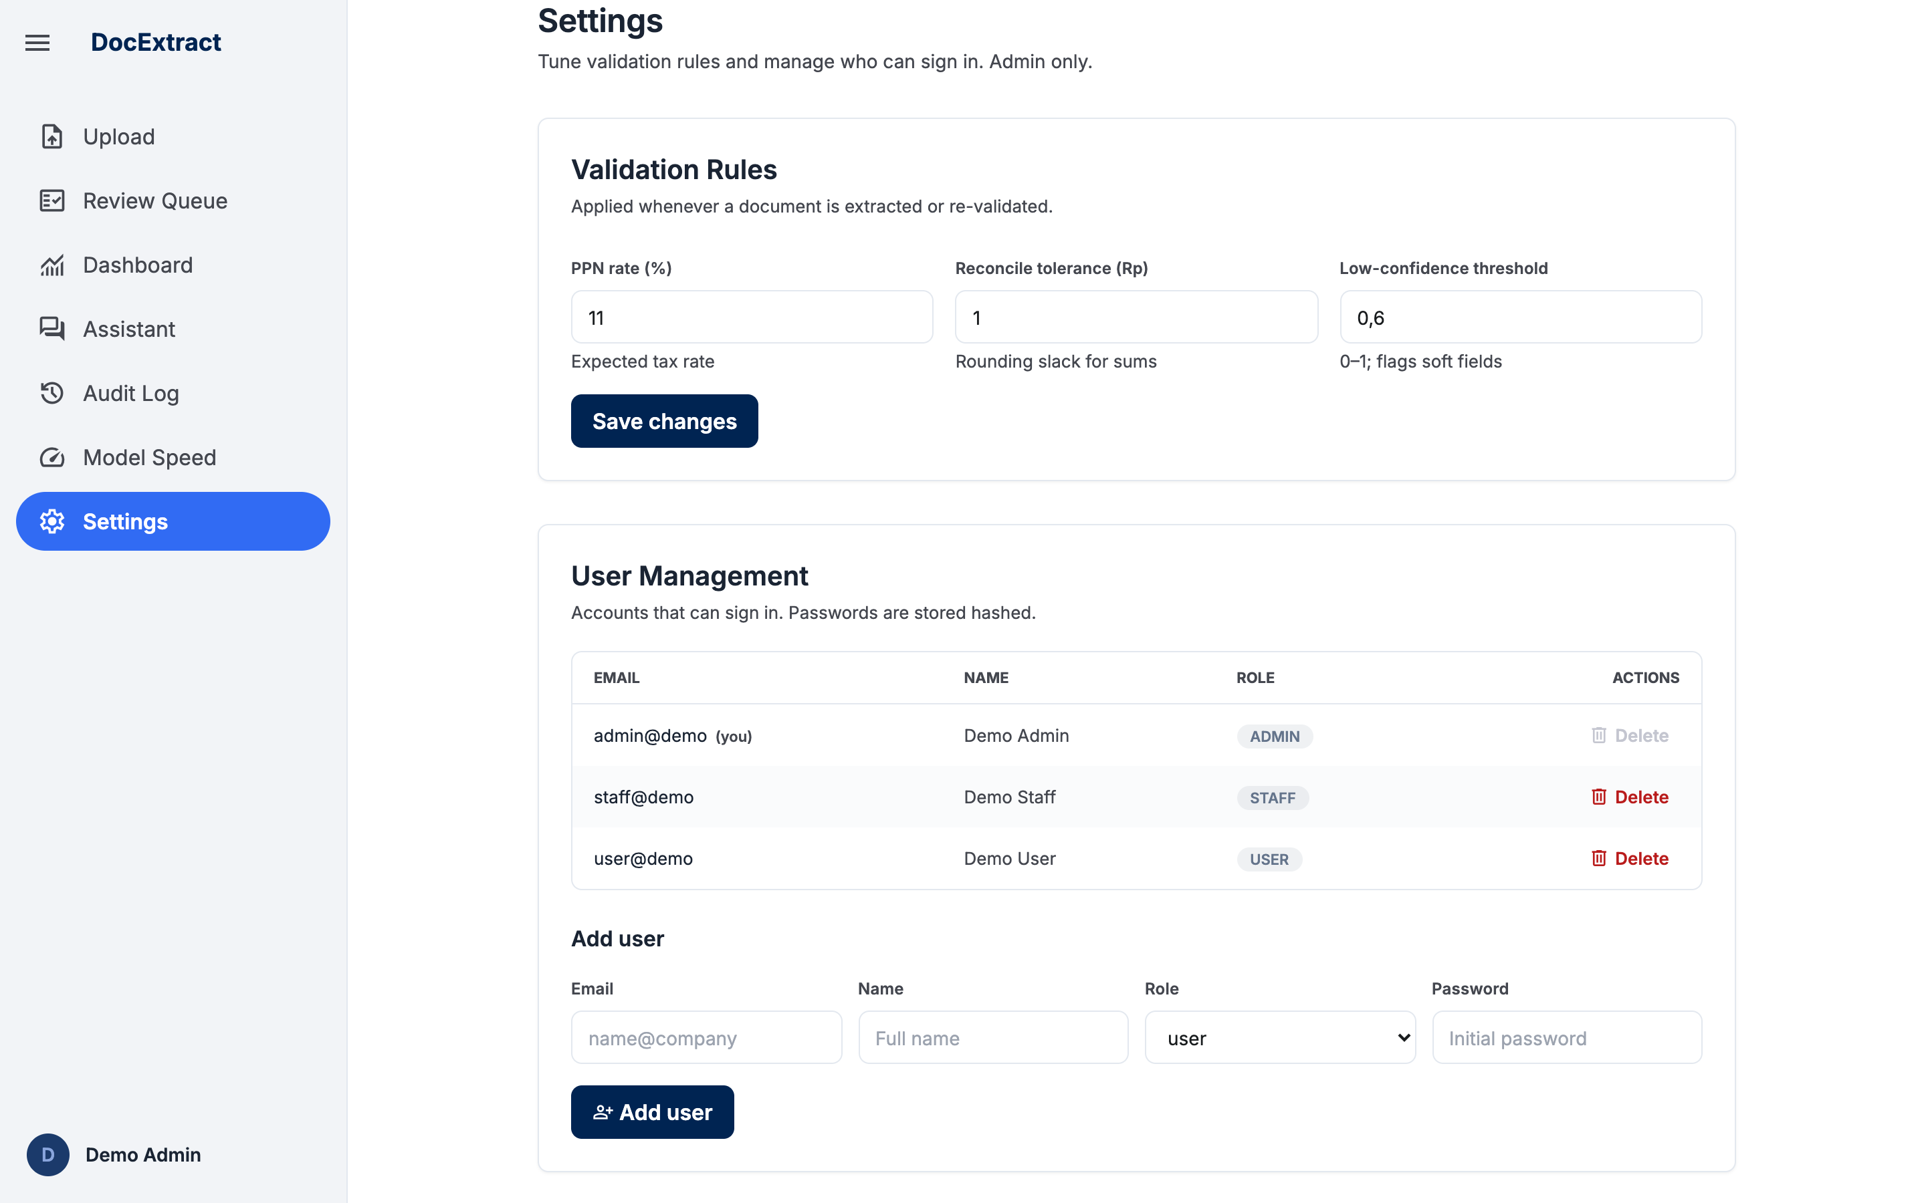
Figure 9 - Settings: validation rules and user management

10. Model Speed (Performance) Page
Helps the team understand where extraction time goes and spot unusually slow documents.
Langkah | Kegiatan
1 | Open the Model Performance page from the sidebar.
2 | Review the "Average Speed" card for overall extraction latency across all tracked documents.
3 | Check the "Breakdown by Doc Type" chart to compare invoice, purchase order, and receipt processing times.
4 | Use the search box, document-type filter, model filter, and speed-range filter to inspect individual entries in the Processing Log table.
5 | The Processing Log shows 10 rows per page - use the "Prev" / "Next" buttons below the table to move between pages.
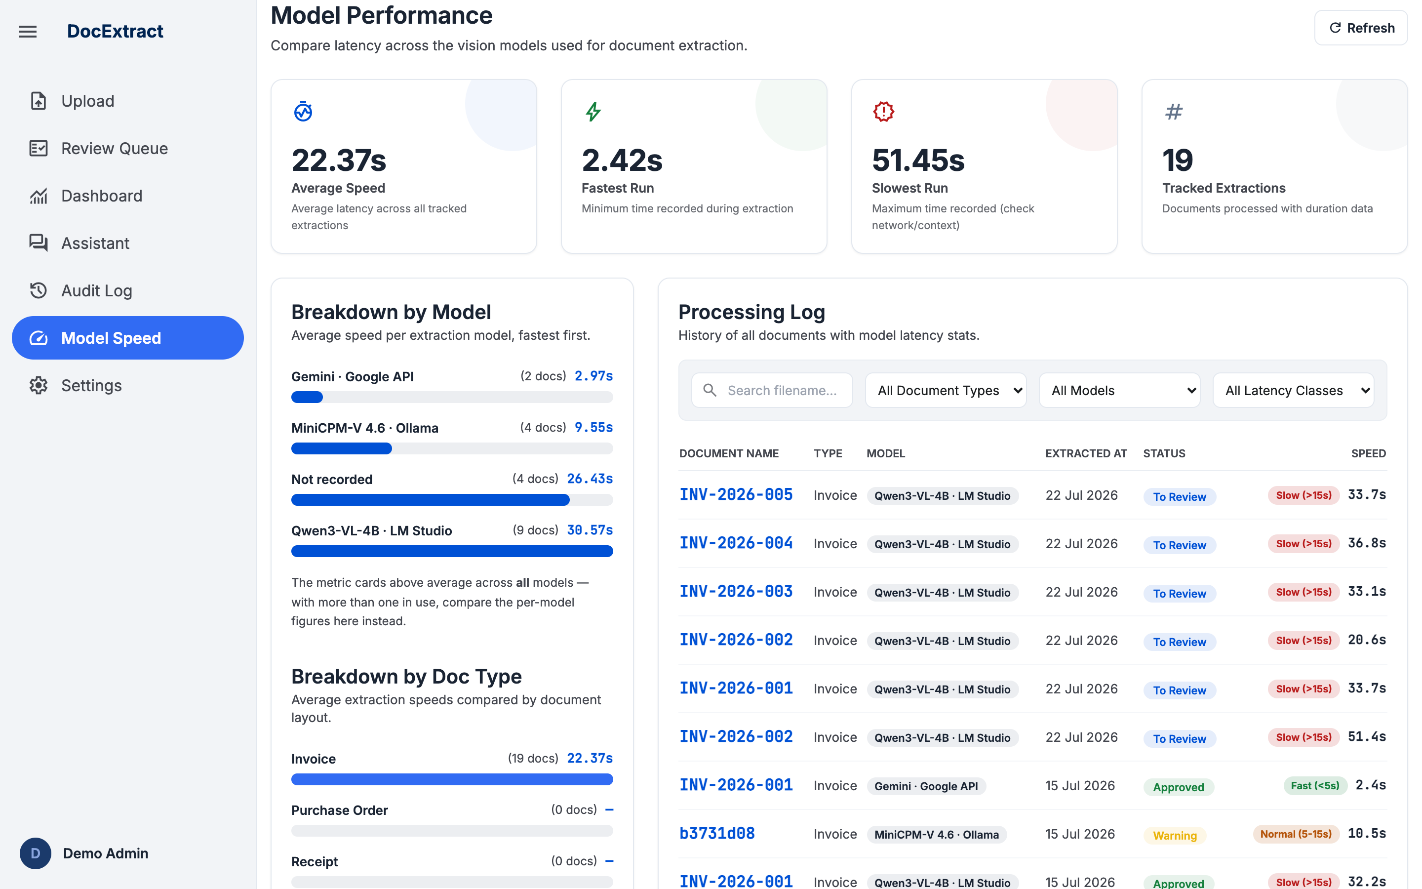
Figure 10 - Model Performance page with per-model breakdown

11. RAG Assistant (Document Chat)
A bonus feature: answers are grounded only in the user's own extracted/approved documents, with citations. Conversations are saved on the server as chat sessions, so your history survives logout and page reloads.
Langkah | Kegiatan
1 | Open the Document Assistant (chat) page from the sidebar.
2 | Type a natural-language question about your documents (e.g., "which documents are flagged?" or "total spend with a given vendor").
3 | Press Send.
4 | Read the answer; citation chips under the answer link back to the source document's Review page.
5 | To limit the assistant to a single document, pick that document in the scope dropdown - answers then use only that document. Changing the scope starts a new chat.
6 | Your previous conversations appear in the chat history sidebar. Click a session to re-open it exactly where you left off; sessions are stored on the server, so they persist after logout or reload.
7 | To remove a conversation, hover over it in the sidebar, click the delete icon, and confirm.
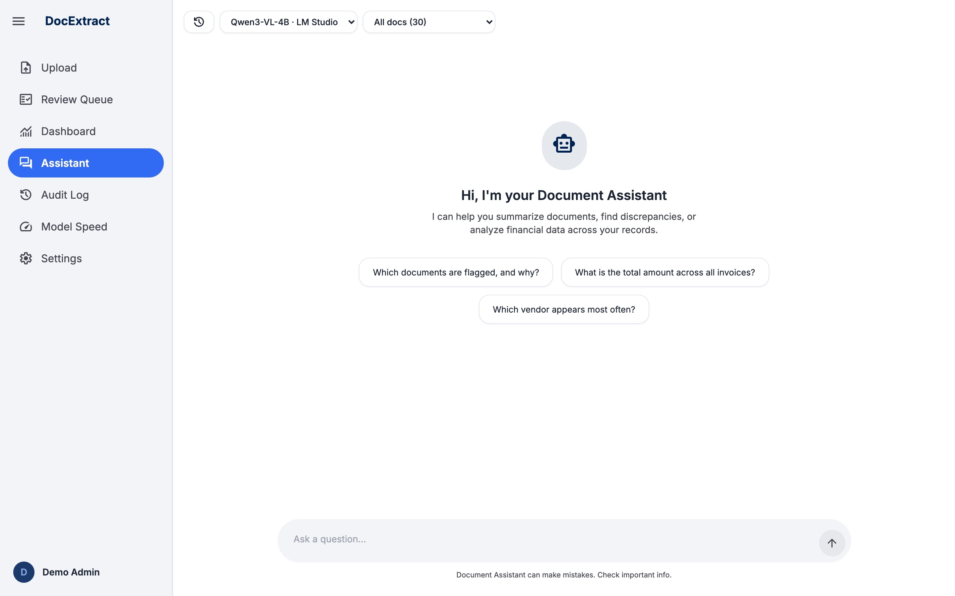
Figure 11 - Document Assistant with model and document-scope pickers

12. Admin Document Deletion
Admins can permanently remove a document from the system. The record and its stored source file are deleted and cannot be recovered, and the action is recorded in the audit log.
Langkah | Kegiatan
1 | Sign in as admin and open the Review page.
2 | Select the document you want to remove from the document list.
3 | Click the "Delete" button, then confirm the permanent deletion in the dialog.
4 | The document disappears from every list immediately, and a "delete" entry is recorded in the audit log.
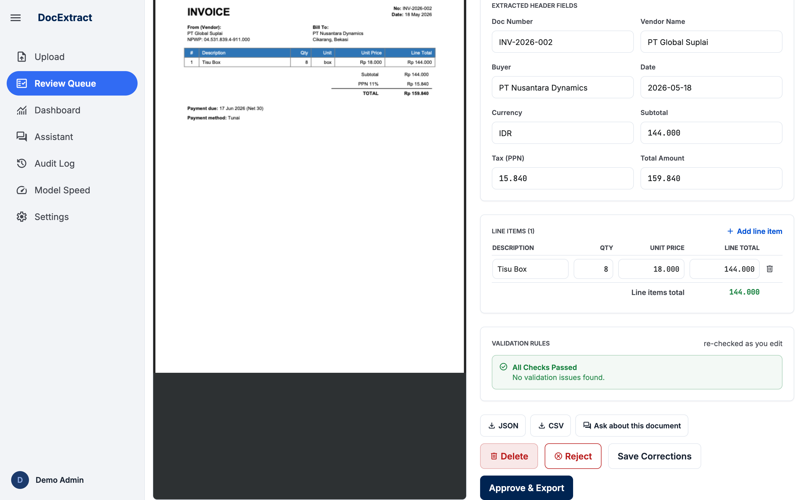
Figure 12 - Delete action on the review screen (admin only)

User Manual Approval
By signing this document, the signatory confirms that User Acceptance Testing (UAT) has been carried out according to the scenarios defined for DocExtract, as documented in this user manual. Signing also indicates agreement with the requirements and the solution exercised during UAT, and its readiness to proceed to the next stage of the project.
Signatures - DocExtract Project
Name | Project Role | Position | Date | Signed

